

Sangfor Kubernetes Engine
Upgrade Guide

Product Version | 1.1.0
Document Version | V1
Released on | Seq. 09, 2024

Sangfor Technologies Inc.

- Product Upgrade
Please make sure to contact SKE R&D technical support to access the environment and perform pre-upgrade operations before proceeding with the upgrade.
- Upgrade Roadmap
Destination  Version  Currently  Version(S) | SKE1.0.0_X86 | SKE1.1.0_X86
SKE1.0.0_X86 | S→T | S→T
SKE1.1.0_X86 |  | S→T
Comments | S→T

- Upgrade Plan Overview
  - Added Feature
- HPA, Horizontal Pod Autoscaler：it automatically adjusts the number of container replicas based on application resource usages to optimize resource utilization and ensure service stability. This feature relies on the Metrics Server plugin to monitor application resource usage and utilizes the HPA controller in kube-controller-manager to dynamically adjust the number of Pods replicas, adapting to load changes in real-time.
- The Harbor image repository has been upgraded from version 2.6.4 to version 2.11, addressing vulnerabilities in open-source components. The chart museum component has been removed in the latest version, along with its associated chart package management functionality. To continue using Harbor for chart package management, refer to the OCI-based chart package management method. Existing chart packages will be re-stored in the image repository using the OCI method.
The harbor-core component has been split into multiple components, maintaining the same number of Pods and containers as the open-source version.
If users prefer not to upgrade, they can manually create a secret named upgrade-harbor-credentials in the Harbor namespace and add the field skip Upgrade=true. The Harbor upgrade step will be automatically skipped during the full package upgrade process.
  - Upgrade Way
Hot upgrades are applicable for scenarios involving upgrades of the same HostOS kernel version, commonly seen in minor version upgrades within the same series (e.g., SKE1.0.0 > SKE1.1.0) or multiple versions released within a short timeframe (e.g., SKE1.0.0 > SKE1.1.0). This approach refers to upgrading all physical hosts in SKE and the user K8S cluster without changing the running location or state of the virtual machines. Utilizing process hot restart technology, the upgrade impact is limited to less than 30 seconds, causing minimal jitter within this period without service interruptions. The in-place hot upgrade method for clusters significantly reduces upgrade time and improves efficiency.
Hot Upgrade is Mainly Applicable to the Following Versions (Common Examples)
Currently Version | Destination Version
SKE 1.0.0 | SKE 1.1.0
- Upgrade Operation
  - Step
- Obtain upgrade guide
- Confirm currently version on customer environment
- Planning upgrade roadmap
- Download version upgrade packets
- Take snapshots of the SKE and K8S clusters and check the environment for stability.
- Check environment
  - Resolve issue
  - Continue to upgrade
- Formal upgrade
  - Upgrade failed, contact R&D
  - Upgrade successful, continued
- Check platform and business
- Upgrade Complete
  - Upgrade Sequence
SCP->>SKE->>K8s cluster
  - Upgrade Considerations
- Check if there are any alert issues in the environment.
- Take snapshots of both the SKE virtual machines and the user cluster virtual machines.
- Before upgrading, ensure that the serial number is still within the upgrade validity period. Upgrades are not allowed without a valid upgrade serial number.
- It is mandatory to apply the container engine SKE patch on SCP before upgrading! Otherwise, the SKE upgrade may fail.
  - Formal Upgrade
- Packets Prepare
Name | Description | Obtain
SKE 1.1.0 pkg | The upgrade package used in the SKE 1.1.0 page upgrade scenario. | https://community.sangfor.com/plugin.php?id=service:download&action=view&fid=47 - /56/all
- Documents Prepare
Name | Description | Obtain
SKE 1.1.0 user manual | SKE Platform Basic Operations and Configuration | User Manual
SKE 1.1.0 upgrade guide | SKE upgrade operation guide | /
- Tools Prepare
Name | Description | Obtain
Chrome | Browser software, installed on the PC side | Obtain it by yourself
Putty | SSH tool | Obtain it by yourself
MD5 | Verify the integrity of the software package | Obtain it by yourself
Serial Number | Before upgrading, confirm that the customer’s environment is within the validity period. If it is not within the validity period, a new purchase is required. | /
- Environment confirm
Class | IP type | IP address | Mask | Mark
SCP | Management IP |  |  | -
SKE | Management
- Coordinate customer resources
During the upgrade process, customer operations personnel are prohibited from logging into SCP to perform operations and maintenance on SKE.
Adequate preparation should be made for potential service interruptions during the upgrade to minimize impact.
- Determine the upgrade time and make adequate preparations for potential business interruptions during the upgrade to minimize impact.
- Ensure there is effective contact information for the on-site person in charge of each device during the upgrade.
- The upgrade site must have a computer (with internet access and stable connectivity to the device), and the computer must have the necessary permissions to run the upgrade client software.
Operation Steps:
- Login into SCP, navigate Kubernetes Engine.
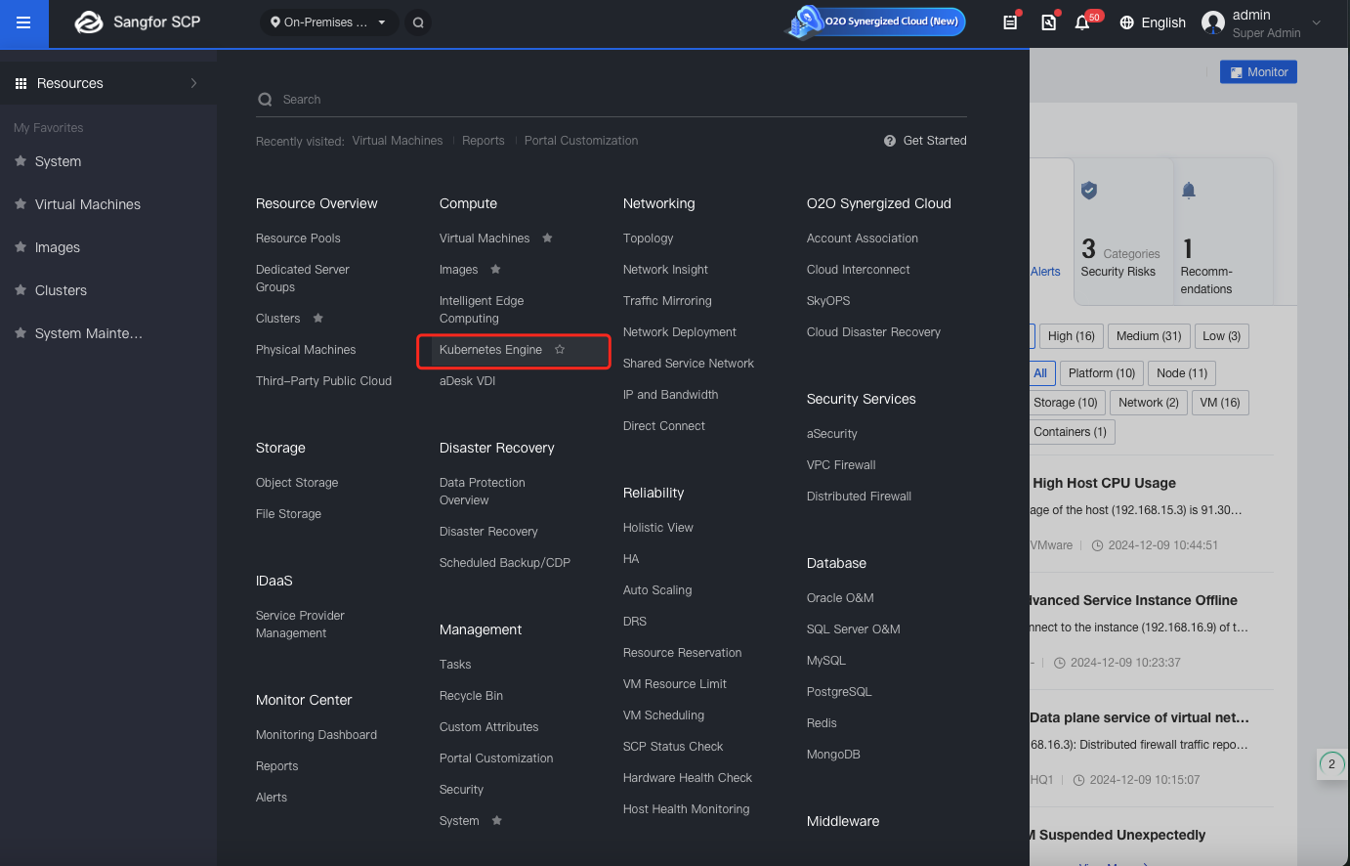
- Navigate Settings.
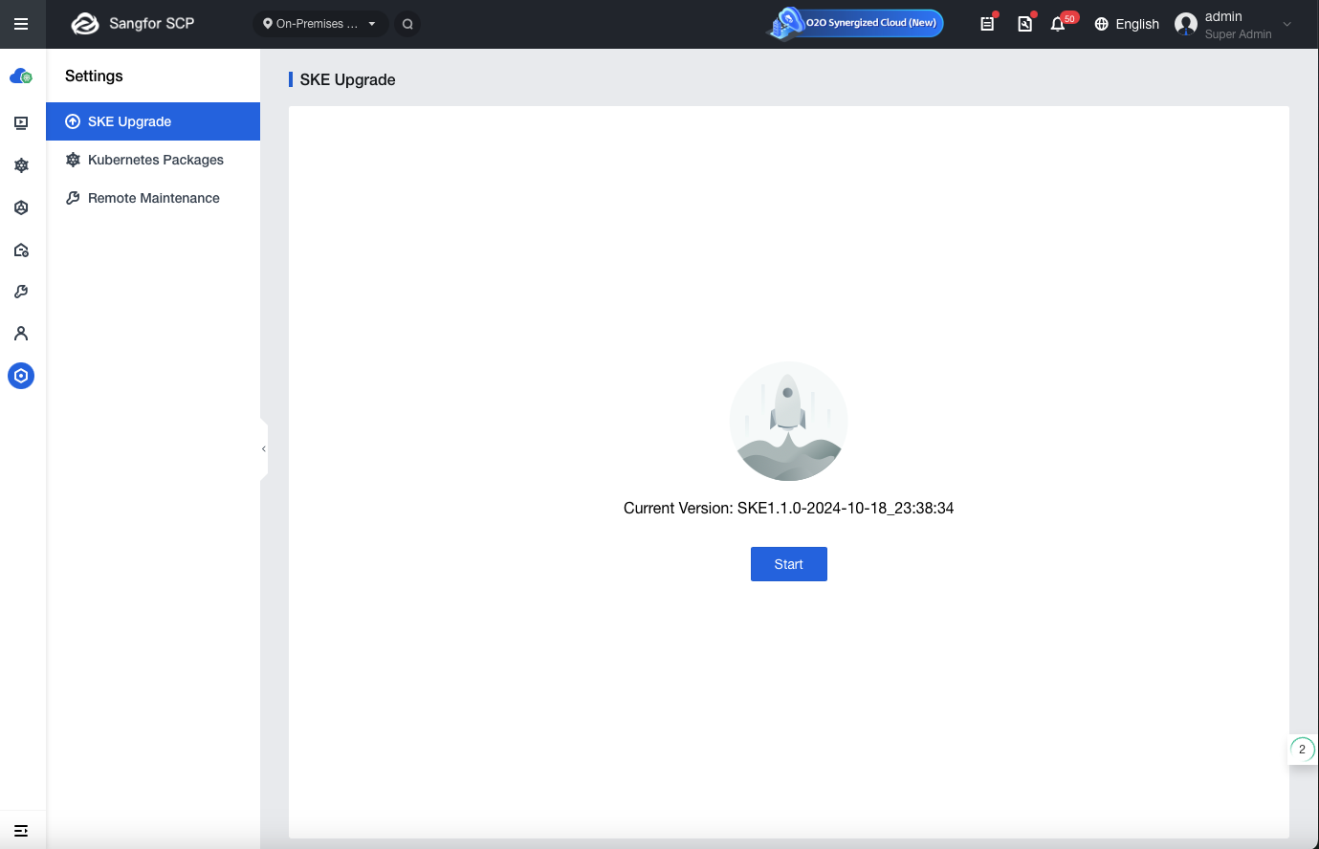
- Click Start to start upgrade process. Wait for the environment check process to complete。
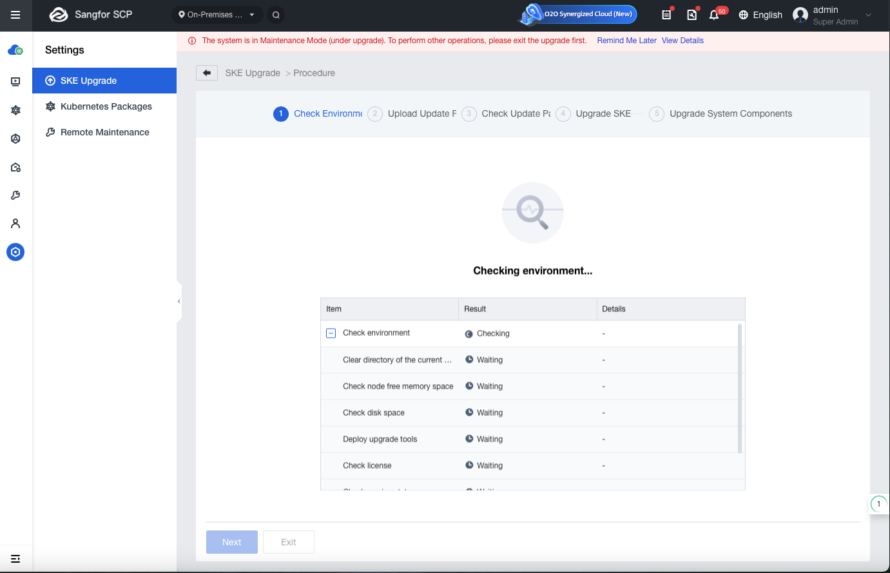
- Upload upgrade packets. Complete the upgrade steps by following the interface instructions
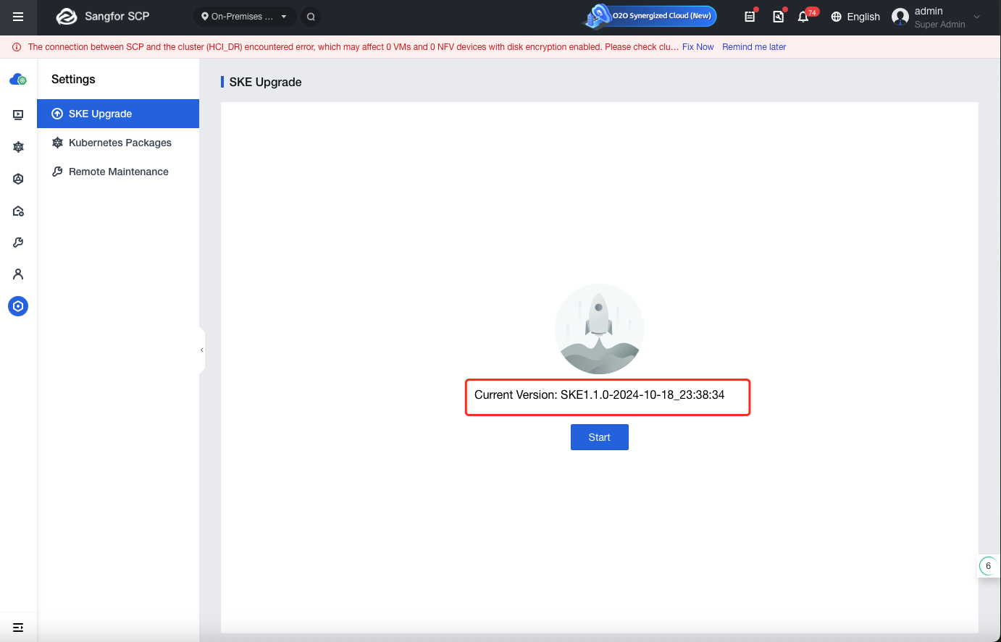
- Exception Handing
  - Common Issue
Issue Description | Version | Countermeasures | Mark
Chart package upgrade failed (page displays “Failed to upgrade container-type services”) | ALL | Chart package upgrade failed (page displays “Failed to upgrade container-type services”). Check the update.log log, move the failed chart package to a temporary directory for backup, then retry the upgrade on the page. Contact the module owner to confirm the cause of the upgrade failure.
Chart package check failed | ALL | This situation is usually caused by a chart package upgrade failure during the previous upgrade, which was skipped through manual intervention. In this case, the status needs to be manually updated to success.  Updated to  {  "systemInfo": {  "cpu": "8",  "mem": "16G"  },  "status": "success"  }
  - Upgrade Failed Handing
Class | Upgrade Phase | Exception Type | Countermeasures | Rollback Possible
Hot upgrade | Check upgrade environment | Upgrade Environment Check Failed | After handling the abnormal situation, retry. If the retry fails or cannot be processed, contact technical support. | Yes, click Exit to rollback upgrade
Hot upgrade | Upload upgrade package | Uploading package failed |  | Yes, click Exit to rollback upgrade
Hot upgrade | Pre-Upgrade Check Phase | Pre-Upgrade check failed |  | Yes, click Exit to rollback upgrade
Hot upgrade | Upgrade phase | Failure due to hci host power loss | After handling the exception, click retry on the page. If the retry fails, contact technical support. | No, you cannot roll back during the upgrade phase. Contact technical support if you want to roll back the version
Hot upgrade | Upgrade phase | Failure due to hci host management network issue
Hot upgrade | Upgrade phase | Failure due to other issues



