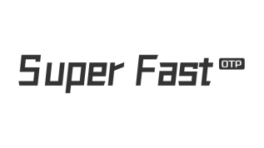

Date: 30 Nov 2023

**Endorsement of Super Fast**

This letter serves to endorse Super Fast for representing our business inmanaging and sending ZALO traffic in Vietnam.

___________

Name:

Title:

Company:

Email: